**Royal Montessori School  
 End of Second Term Examination**

**Subject: Phonics Class______**

**Name___________________________________ Date:_______**

**Trace the pattern**



**Trace the letters from ‘a’ to ‘z’**

1. a b c d
2. e f g h
3. i j k l m n
4. o p q r s
5. t u v w
6. x y z

Make the sound of the following letters and match them with their kind

1. b w
2. C b
3. e c
4. g e
5. h g
6. x h
7. w x

Mention the name of the pictures and match them to the correct beginning character

1. 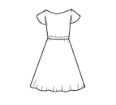

f

1. 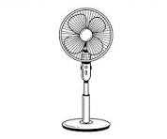

e

1. 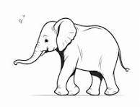

d

Look for the letter or sound code and use it to color the flower

o

i

t

c

a

d

e

s

f

n

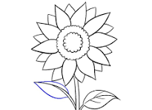

e

n

i

f

s

a

d

o

c

t

**Royal Montessori School  
 End of Second Term Examination**

**Subject: Colours Class______**

**Name___________________________________ Date:_______**

1. What colour is the

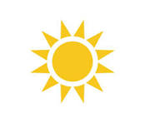 a. Red b. yellow

What is the color of the bottle?

2. 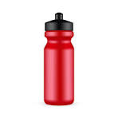a. yellow b. red

1. 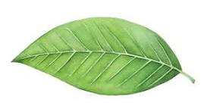a. green b. purple
2. Use yellow to colour the star

**Royal Montessori School  
 End of Second Term Examination**

**Subject: Shapes Class______**

**Name___________________________________ Date:_______**

Answer correctly with the of your teacher



This shape is a … (a) heart (b) star

1. This shape is a… (a) star (b) other answers
2. This shape is a… (a) rectangle (b)star

This shape is a … (a) circle (b) square

1. What shape is this? (a)Triangle (b)others

**Royal Montessori School  
 End of Second Term Examination**

**Subject: Colours Class______**

**Name___________________________________ Date:_______**

Answer the following questions

Choose the correct answer out

1. What are some colours you see in the Ghana flag?

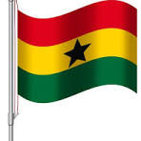 (a) red (b) pink

1. What is the colour of the star in question one(1) (a) green (b) black
2. The colours of the flag are red, yellow, green, and black (a)true (b) false
3. What is the colour of the sun? (a) yellow (b)blue
4. 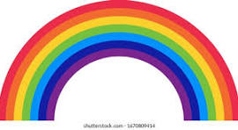 How many colours can you see in the rainbow (a) 7 (b) 2 colours
5. What colour is a ripe banana (a) purple (b) yellow
6. What colour is the elephant (a) purple (b) grey

Colour the following objects with their right colours

1. 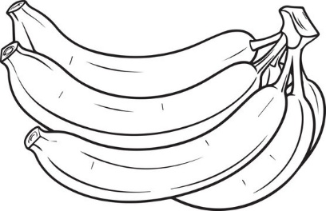 plantain
2. 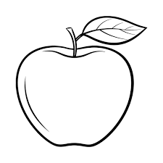 apple
3. 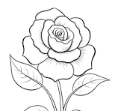 sunflower

Colour the flower below with the colour

yellow

green

Red



y

r

g

g

**Royal Montessori School  
 End of Second Term Examination**

**Subject: Literacy Class______**

**Name___________________________________ Date:_______**

**Trace the patterns**



Match the object to their first sound and color them

1. 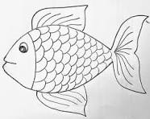 fish

b

1. 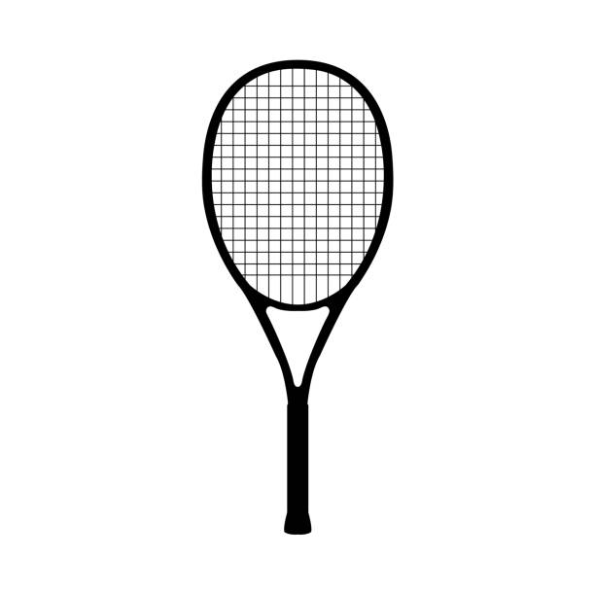bat

f

1. 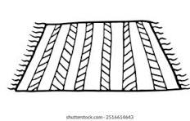mat

c

1. 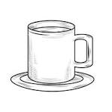cup

d

m

1. 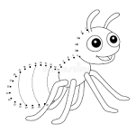ant

i

1. 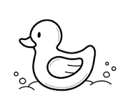duck
2. 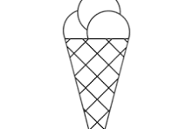ice cream

a

**Royal Montessori School  
 End of Second Term Examination**

**Subject: Environmental studies Class______**

**Name___________________________________ Date: __________**

1. The school is where we study or to learn and become good people in future. (a) True (b) false

1. Living room, bedroom, kitchen, and bathroom are part of the rooms on the home. (a) It is not true (b) It is true
2. Something that can be to found in the school classroom are …………………
3. Chairs, tables and books b. Ladel, watering and car
4. Somethings can be seen, felt and touched. Examples are swing, dress, trees, and pencils. (a) True (b)False

1. Some people living in our homes are..
2. Father, mother and children b. Tiger, lion and snakes
3. Father pays the school fees and mother ….
4. Cooks and baths the kinds b Sleeps in the house
5. The people who worship the small gods in the shrine are called ……………….
6. Fetish priest b. Pastors
7. When we go to church, it is the … who preach to us. a. Iman b. Pastor
8. During prayers in the mosque, it is the ………. who leads.
9. Iman a. Fetish priest
10. Some special places in our community are ….
11. Chief palace a. Trees
12. The market is one of the special places in our community.
13. It is true a. It is not true
14. In Ghana the ………... is our symbol.
15. Ghana flag b. The Indian flag
16. Girls wear skirts and the boys wear ……………
17. Gown b. Pair of knickers
18. Which of these can be worn by boys and girls
19. Gown b. Wrist watches
20. We have to keep our finger nails short and clean all the time to …………………
21. Avoid germs from entering b. Fall sick all time
22. We should always put the biscuits rubber and kalyppo box in or on …………
23. Dustbin b. Floor
24. We should brush our teeth ………………….
25. In the morning and evening b. Only in the morning
26. Color the tree

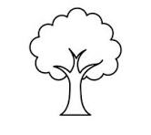

1. Color the rain and cloud

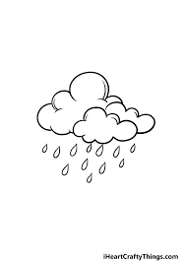

1. Identify and color

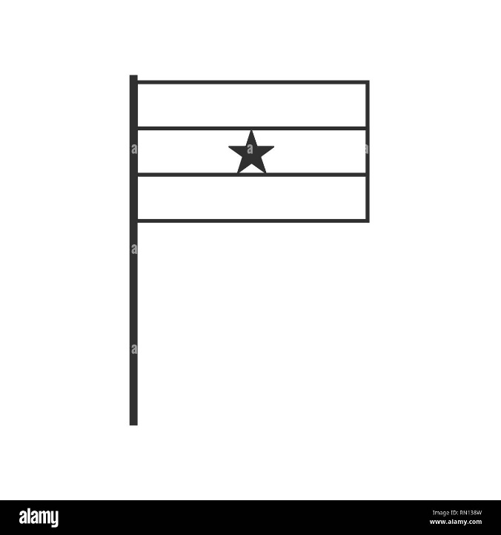 a. Ghana flag b. tree

Describe the picture and color

1. 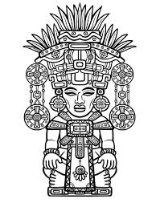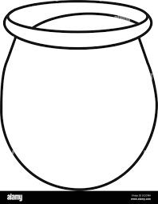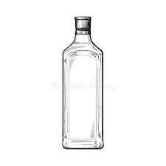
2. This is a shrine b. this is a market
3. 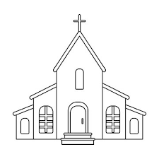

Identify the picture and colour

1. This is s church b. other things

**Royal Montessori School  
End of Second Term Examination**

**Subject: Tracing and Writing of Numerals Class______**

**Name___________________________________ Date:_______**

**Identify the body parts**

1. 2.

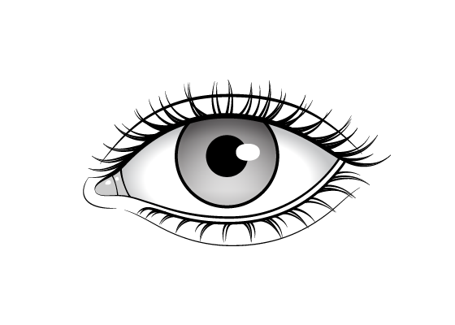 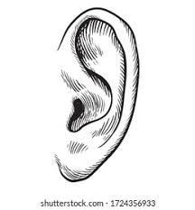

1. leg b. eye a. ear b. nose
2. .

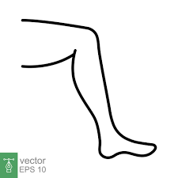

1. mouth b. leg

4. The eye is used for … a. smelling b. seeing

5. The ears helps us to a. hear b. smell

6. A flower is a part of a plant a. True b. false

7. A rose flower and sunflower are examples of flowers a. True b. false

**Living things are things that can breathe, eat, drink, grow and move ………….**

8. Is plant a living thing? a. True b. false

9. Dog is one of the living things

a. True b. False

10. Human being is a living thing a. true b. false

**Trace and color the types of weather**

11.  rainy weather

12. 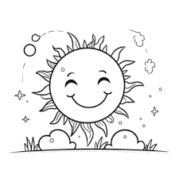 sunny weather

1. During the dry season, a. leaves go dry b. there is lots of rain
2. During rainy season, a. there is lots of rain b. there is no rain
3. Bell, drum and car are part of things that make sound  
   a. It is true b. It is never true
4. The garden is a small farm behind a. true b. false
5. Some garden tools are

a. spoon and plate b. garden fork and watering can

1. A fruit is a part of the plant which contains seeds and can be eaten as food a. false b. true
2. Oranges, strawberry and grapes are fruits  
   a. true  
   b. false
3. Vegetables are also part of plant that grow into food  
   a. true b. not true

**21.** Vegetables like tomato, okra, cabbage and carrots give us energy when we eat them  
a. false b. true

**22.** All animals that have feathers and wings are called birds. Some are:  
a. cock, hen and parrot b. dog, cat and mouse

**23.** Some types of animals live in our homes and are useful to us. These animals are called  
 a. wild animals b. domestic

**24.** We get bags, slippers, belts and sweaters from animals.  
 a. It is not true b. It is true

**25.** ______ is what people and animals eat when they are hungry  
a. Food b. Stones

**26.** We ___ when we become thirsty  
a. drink water b. eat food

**27.** We get water from.. a. river, rain and well b. trees and animals

**28.** Make a picture of a sun flower using poster colours in the space below

**Trace and write the numerals 11-20**

|  |  |  |  |  |  |  |  |  |  |
| --- | --- | --- | --- | --- | --- | --- | --- | --- | --- |
| 11 | 12 | 13 | 14 | 15 | 16 | 17 | 18 | 19 | 20 |
|  |  |  |  |  |  |  |  |  |  |
| 11 | 12 | 13 | 14 | 15 | 16 | 17 | 18 | 19 | 20 |
|  |  |  |  |  |  |  |  |  |  |

Write the numeral 1-20 by completing the table

|  |  |  |  |
| --- | --- | --- | --- |
|  | 2 |  | 4 |
| 5 |  | 7 |  |
|  | 10 | 1 | 12 |
|  | 14 | 15 |  |
| 17 |  | 19 |  |

Trace the following shapes

1. Square b. Trapezium

**Royal Montessori School  
 End of Second Term Examination**

**Subject: Natural Science Class______**

**Name___________________________________ Date:_______**

**Choose the correct answer**

Identify the following numerals

1. 1 a. one b. two
2. 2 a. two b. four
3. 3 a. four b. three
4. 5 a. five b. one
5. 4 a. three b. four

Trace the numerals below



Colour the numbers

1. 2 9. 3